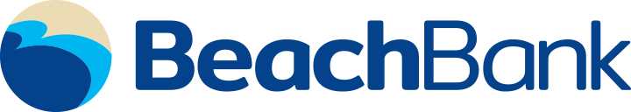

BEACH BANK CONVERSION
COMMONLY ASKED QUESTIONS

Why is The First Bank joining forces with Beach Bank?
The First Bank has entered into a definitive agreement with Beach Bank in an effort to better serve our clients and to provide stronger returns to our shareholder.

Who is The First Bank?
The First Bank is headquartered in Hattiesburg, Mississippi. Founded in 1996, The First Bank has operations in Mississippi, Louisiana, Alabama, Florida and Georgia. Twenty six years ago, our founding Directors started our Bank with a vision of creating a regional community bank that focused on growing our business by building long term relationships with clients and generating superior returns for our shareholders. The Company’s stock is traded on NASDAQ Global Market under the symbol FBMS. Additional information is available on the Company’s website: www.TheFirstBank.com

When will the legal closing take place?
The legal closing is targeted for the 3rd Quarter of 2022 with systems conversions to follow during the 4th quarter of 2022.

Is there anything I need to do right now?
Yes. We encourage you to review and update your current email, mailing address and account information within your Online Banking account or at your local branch to ensure that it is up to date. Important updates will be sent to you throughout the conversion process and we do not want you to miss any of this information.

Will I get notifications?
Yes. You will receive periodic updates throughout this process. You will receive a booklet prior to conversion with information regarding any changes that may occur. All updated information will also be placed on our website www.TheFirstBank.com.

Where are The First branches located?
The First has 90 branch locations in Mississippi, Alabama, Louisiana, Florida, and Georgia. Attached is a map of our combined locations. You can find a complete list of all The First Bank locations on our website www.TheFirstBank.com/locations.

Will I still use my current checks and debit card?
Yes, please continue to use your current checks and debit card at this time. You will continue to conduct business as usual at your branch location.

How does The First Bank support its communities?
Contributing to the quality of life in the communities that we serve is built into our Company’s Mission Statement. We take great pride in supporting local interests in our business and philanthropic efforts. Attached is a copy of our most recent Corporate Social Responsibility report that highlights many of these activities.

